TECHNISCHE HOCHSCHULE KÖLN

Faculty of Information, Media, and Electrical Engineering

EVALUATION OF 5G OPEN RADIO ACCESS NETWORK SIMULATION

ENVIRONMENTS

Master Research Project

MSc. Communication Systems and Networks

Deutz Campus

**Supervisor** **Candidate**

Prof. Dr. Andreas Grebe Md Nur Mohammad

Faculty of Information, Media, and Electrical Engineering Student ID:11145131

Cologne, 10th May 2023

Contents

…………………… ……………….Table of contents……………………………………….

Abbreviations

O-RAN= Open Radio Access Network

RIC=RAN Intelligent Controller.

NSF= Network Slicing Function.

RRC= Radio Resource Control.

SDAP= Service Data Adaptation Protocol.

PDCP= Packet Data Convergence Protocol.

ONAP =Open Network Automation Platform.

Abstract

…………………………………. Short summary of research project ……………………

Chapter 1

Introduction

………………………………….. Background information of 5G O-RAN…………………….

…………………………………. Research method and tools or technics……………………...

………………………………….Research and research result…………………………………

Chapter 2

O-RAN Alliance and O-RAN Ecosystem

2.1 O-RAN Alliance Overview

The O-RAN Alliance was founded with the aim of promoting openness and intelligence in the Radio Access Network (RAN) industry. The organization has quickly gained momentum, with over 200 members including major mobile operators, network equipment vendors, and system integrators.

One of the key objectives of the O-RAN Alliance is to develop open interface specifications that enable multi-vendor interoperability and support the deployment of virtualized RAN solutions. These open interfaces allow network operators to select best-of-breed components from different vendors, avoiding vendor lock-in and promoting competition in the industry.

To ensure that RAN components from different vendors are interoperable and compliant with the Alliance's specifications, the organization provides testing and certification services. This helps to reduce the risk of vendor lock-in and enables network operators to choose the best components for their specific needs.

The O-RAN Alliance has also developed several use cases that showcase the benefits of an open RAN architecture. These use cases cover a range of scenarios and demonstrate how an open and interoperable RAN can be used to provide better coverage and more flexible deployment options.

The O-RAN Alliance seeks to create a more open and intelligent RAN by:

1. Open RAN architecture: The O-RAN Alliance is focused on promoting an open RAN architecture that enables network operators to select best-of-breed components from different vendors. This approach allows network operators to avoid vendor lock-in and promotes competition in the industry.
2. O-RAN specifications: The Alliance develops and maintains a set of specifications that define the interfaces between different RAN components. These specifications are designed to be open and interoperable, allowing network operators to mix and match components from different vendors.
3. O-RAN testing and certification: The Alliance provides testing and certification services to ensure that RAN components from different vendors are interoperable and compliant with the Alliance's specifications. This helps to reduce the risk of vendor lock-in and enables network operators to choose the best components for their specific needs.
4. O-RAN use cases: The Alliance has developed several use cases that demonstrate the benefits of an open RAN architecture. These use cases cover a range of scenarios, from rural coverage to indoor deployments, and showcase the advantages of open and interoperable RAN components.
5. O-RAN market momentum: The O-RAN Alliance has gained significant momentum in recent years, with many major mobile network operators and network equipment vendors joining the organization. The Alliance's focus on open and interoperable RAN components has struck a chord with many stakeholders in the industry who are seeking more choice and flexibility.

Overall, the O-RAN Alliance is playing a key role in driving innovation and competition in the RAN industry. Its focus on openness and interoperability is helping to create a more diverse and vibrant market, while its testing and certification services are ensuring that RAN components from different vendors work together seamlessly.

2.1.1 Release Specifications

The O-RAN Alliance has released several specifications and technical reports since its inception. These releases are designed to promote interoperability and support the development of open and intelligent RAN solutions. Here are some of the key releases from the Alliance:

1. O-RAN Architecture: This release provides an overview of the O-RAN architecture, including the key components and interfaces that make up the system. The architecture is designed to be flexible and scalable, supporting a wide range of deployment scenarios.
2. O-RAN Use Cases: The O-RAN Alliance has developed several use cases that demonstrate the benefits of an open and interoperable RAN. These use cases cover a range of scenarios, from indoor small cells to rural deployments, and highlight the flexibility and cost savings that can be achieved with an open RAN architecture.
3. O-RAN Radio Intelligent Controller (RIC) Functional Description: The O-RAN RIC is a key component of the Alliance's architecture, providing a centralized intelligence layer that can be used to manage and orchestrate RAN resources. This specification provides a detailed description of the RIC's functionality and interfaces.
4. O-RAN Testing and Integration: The O-RAN Alliance provides testing and integration services to ensure that RAN components from different vendors are interoperable and compliant with the Alliance's specifications. This release provides an overview of the testing and certification process, as well as information on the testing tools and environments used.
5. O-RAN Software Community: The O-RAN Alliance has established a software community to promote the development of open-source software for the RAN industry. The community is focused on developing software that supports the Alliance's specifications and promotes interoperability between different vendors.

These releases demonstrate the O-RAN Alliance's commitment to openness and interoperability in the RAN industry. By providing clear specifications and guidelines, the Alliance is helping to create a more diverse and competitive market, which ultimately benefits network operators and end-users alike.

2.1.2 O-RAN Software Community

The O-RAN Software Community is a collaborative project launched by the O-RAN Alliance to facilitate the development of open-source software for the RAN industry. The community is designed to bring together developers, vendors, and network operators to work on software projects that support the O-RAN Alliance's specifications and promote interoperability between different RAN components.

The community's primary focus is on developing software for the O-RAN Intelligent Controller (RIC), which is a key component of the O-RAN architecture. The RIC provides a centralized intelligence layer that can be used to manage and orchestrate RAN resources, and the community is working on developing software that supports the RIC's functionality and interfaces.

In addition to the RIC, the community is also working on other software projects that support the O-RAN Alliance's specifications. These include projects related to network management, performance monitoring, and testing and integration.

One of the key benefits of the O-RAN Software Community is that it provides a collaborative environment for developers to work on software projects that are aligned with the O-RAN Alliance's goals. By working together, developers can share knowledge and resources, and can ensure that their software is compatible with other components of the RAN ecosystem.

Overall, the O-RAN Software Community is a key initiative that is helping to drive innovation and openness in the RAN industry. By promoting the development of open-source software, the community is helping to create a more diverse and competitive market, which ultimately benefits network operators and end-users alike.

2.1.3 Architectural Release

Accordingly, the O-RAN architecture contains several components which are developed by O-RAN Alliance software community.

There are the releases with release dates:

1. A Release (Amber release) ---------------------------------- Release date: November 2019
2. B Release (Bronze Release) --------------------------------- Release date: Jun 2020
3. C Release (Cherry Release) --------------------------------- Release date: December 2020
4. D Release (Dawn Release) --------------------------------- Release date: July 2021
5. E Release (Emerald Release) ------------------------------- Release date: December 2021
6. F Release ------------------------------------------------------- Release date: July 2022
7. G Release ------------------------------------------------------ Release date: December 2022
8. H Release ------------------------------------------------------- Upcoming

2.1.4 Release Notes

* RAN Intelligent Controller Applications (RICAPP) features.
* Near Real time RAN Intelligent Controller (RIC) features.
* Non-Real time RAN Intelligent Controller (NONRTRIC) features.
* Operations and Maintenance (OAM) features.
* O-RAN Central Unit (OCU) features.
* O-RAN Distributed Unit High Layers (ODUHIGH) features.
* O-RAN Distributed Unit Low Layers (ODULOW) features.
* Infrastructure (INF) features.
* Integration and Testing (INT) features.
* Service Management and Orchestration (SMO) features.

2.2 Architecture of O-RAN

The Logical Architecture of Open RAN is designed to be a flexible and modular system that can support a wide range of deployment scenarios. At its core, the architecture is based on a set of standardized interfaces and protocols that enable interoperability between different RAN components.

The architecture is designed to be split into two main domains: the Radio Domain and the Non-Radio Domain. The Radio Domain includes the base station and related equipment, while the non-Radio Domain includes the management and orchestration functions that are responsible for controlling the RAN resources.

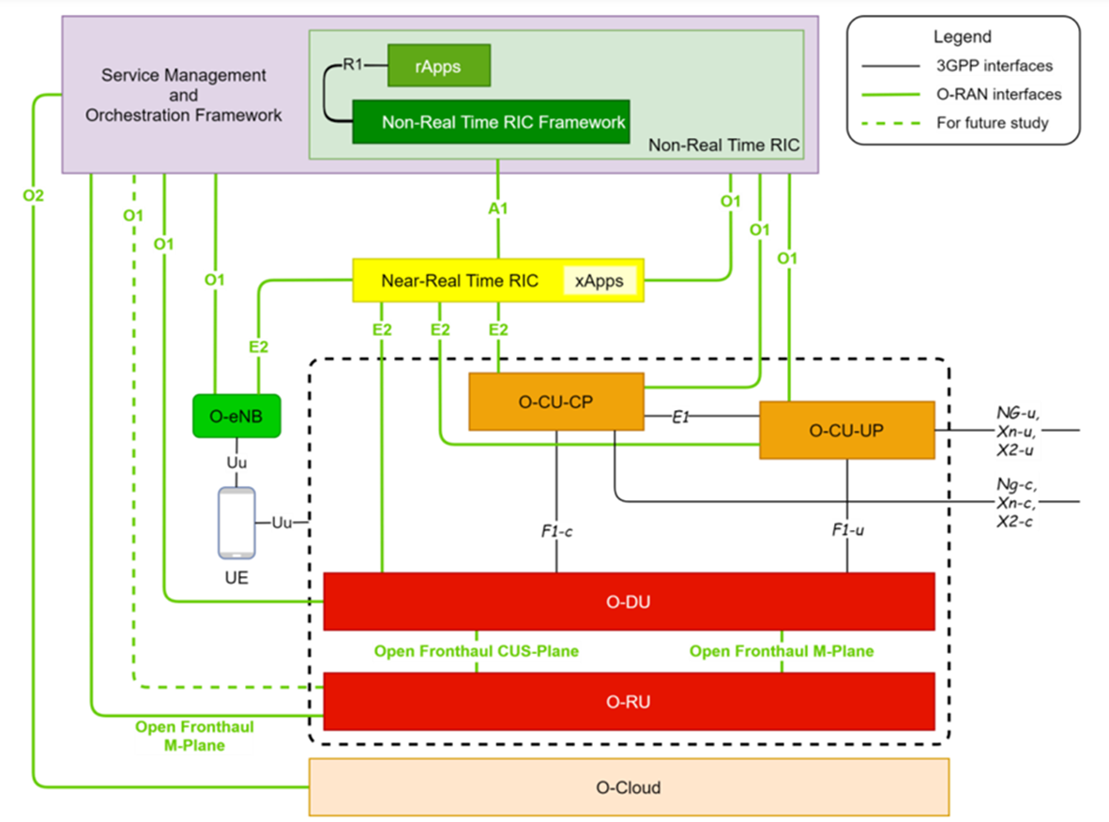

Figure: Logical Architecture of Open RAN

Service Management and Orchestration (SMO)

Service Management and Orchestration (SMO) is a functional area in the O-RAN architecture that is responsible for managing and orchestrating services and applications across the RAN network. The SMO layer is designed to work in conjunction with other functional areas, such as the Management and Orchestration (MANO) layer and the Network Slicing Function (NSF) layer, to ensure that services and applications are deployed and managed effectively.

The Service Management and Orchestration (SMO) layer within the O-RAN architecture plays a crucial role in enabling the non-RT RIC to access specific functionalities related to RAN optimization actions, such as collecting Performance Measurements (PM) through O1 and O2 interfaces. However, SMO also has a much broader mandate, including the orchestration of the Network Functions Virtualization Infrastructure (NFVI), and managing the lifecycle of O-RAN network elements, which can be either Virtual Network Functions (VNFs) hosted in specific locations of the O-Cloud infrastructure or Physical Network Functions (PNFs) exposed by cell sites.

For non-virtualized parts, such as O-RU functionalities that are related to area coverage and must be placed at cell sites, the SMO supports the deployment of physical network elements on dedicated physical resources with management through the O1 interface. However, for virtualized network elements, the SMO has the capability to interact with the O-Cloud to perform network element lifecycle management. For example, it can instantiate the virtualized network element on the target infrastructure through the O2 interface or indicate the selected geo-location for each VNF to be instantiated.

To ensure smooth communication between the deployed network elements, the SMO is also responsible for IP addressing, network reconfiguration, and system updates. To support a range of deployment solutions, the Operation and Maintenance architecture defined by O-RAN describes in detail the requirements necessary for the SMO framework to be provided by third-party Network Management Systems (NMS) or orchestration platforms, such as the Linux Foundation's Open Network Automation Platform (ONAP).

Overall, the Service Management and Orchestration framework is a critical component of the O-RAN architecture, providing a standardized interface and protocols for managing and orchestrating services and applications across the RAN network. With its ability to interact with both virtualized and physical network elements, the SMO enables greater interoperability, flexibility, and efficiency, ultimately benefiting both network operators and end-users.

near-real time RAN Intelligent Controller (near-RT RIC)

In the O-RAN architecture, the near-RT RIC, or near-real-time RAN Intelligent Controller, serves as a crucial function for enabling real-time control and optimization of O-RAN resources via fine-grained data collection and actions through the E2 interface.

non-real time RAN Intelligent Controller (non-RT-RIC)

The non-RT RIC, or non-real-time RAN Intelligent Controller, is responsible for non-real-time control and optimization of RAN resources, including AI/ML workflow such as model training and updates, and policy-based guidance of applications/features in near-RT RIC.

O-RAN Central Unit (O-CU)

The O-RAN Central Unit, or O-CU, is a logical node that houses the RRC, SDAP, and PDCP protocols. Specifically, the O-CU-CP hosts the RRC and control plane part of the PDCP protocol, while the O-CU-UP hosts the user plane part of the PDCP protocol and the SDAP protocol.

O-RAN Distributed Unit (O-DU)

The O-RAN Distributed Unit, or O-DU, is a logical node that houses the RLC/MAC/High-PHY layers based on a lower layer functional split.

O-RAN Radio Unit (O-RU)

The O-RAN Radio Unit, or O-RU, is a logical node that houses the Low-PHY layer and RF processing based on a lower layer functional split. This is like 3GPP's "TRP" or "RRH," but is more specific in including the Low-PHY layer, such as FFT/iFFT and PRACH extraction.

O1 Interface

O1 is an interface that facilitates the communication between management entities in the Service Management and Orchestration Framework and O-RAN managed elements. Its primary purpose is to enable the operation and management of these elements by supporting functions such as FCAPS management, software management, and file management. The O1 interface provides a standardized and secure means of accessing and controlling O-RAN network elements, ensuring efficient and effective management of these critical components.

2.3 RAN Intelligent Controller

RAN Intelligent Controller (RIC) is a logical function that provides near-real-time control and optimization of Radio Access Network (RAN) resources through fine-grained data collection and actions over E2 interface. RIC architecture is based on the principles of Open RAN and is designed to be flexible, scalable, and vendor neutral.

The RIC is composed of two main elements: near-RT RIC and non-RT RIC. The near-RT RIC provides near-real-time control and optimization of RAN elements and resources, such as radio resource allocation, traffic steering, and interference management. On the other hand, the non-RT RIC enables non-real-time control and optimization of RAN elements and resources, including AI/ML workflows for model training and updates, and policy-based guidance of applications/features in near-RT RIC.

**Service Management and Orchestration (SMO)**

rApps

AI/ML Models

RAN Analytics

Non-RT RIC Framework

Open APIs

Policies/Guidance

**Near-RT RIC**

Open APIs

RAN Optimization

xApps

RAN Control

Near-RT RIC Framework

Open APIs

**Directives/Control**

**O-RAN**

**Distributed Unit (O-DU)**

**O-RAN**

**Central Unit (O-CU)**

Figure: RAN Intelligent Controller Architecture

The RIC architecture also includes other key elements such as O-CU, O-CU-CP, O-CU-UP, O-DU, and O-RU. O-CU is the central unit in the RAN that hosts RRC, SDAP, and PDCP protocols. O-CU-CP is the control plane part of the PDCP protocol, while O-CU-UP hosts the user plane part of the PDCP protocol and the SDAP protocol. O-DU hosts RLC/MAC/High-PHY layers based on a lower layer functional split, while O-RU hosts Low-PHY layer and RF processing based on a lower layer functional split.

RIC architecture also includes O1 interface between management entities in Service Management and Orchestration Framework and O-RAN managed elements. O1 interface is used for operation and management, by which FCAPS management, software management, file management, and other operations are achieved.

2.3.1 Near-RT RIC (theoretically)………………………………….

2.3.2Non-RT RIC (theoretically) .…………………..….………….

5 RIC Environment Set-up and Deployment

5.1 Infrastructure Preparation and Deployment of near-RT RIC.

Hardware: 1. Ubuntu 20.4

2. 16 GB RAM

3. 50GB Disk

4. 8 CPU

Software: 1. kubernetes v1.16

2. Docker and docker-compose (latest)

3. Helm and base chart -v3.5

5.1.1 Prerequisites Installation of near-RT RIC.

Steps:

1. Start by preparing a fresh Ubuntu 20.04 environment specifically tailored for near-RT RIC deployment.
2. Install Kubernetes, helm, and the necessary base chart, ensuring they are properly configured for the upcoming Near-RT RIC deployment.
3. Proceed with the installation of near-RT RIC, taking care to follow the recommended guidelines and dependencies.
4. Compile and establish a seamless connection to the O-RAN E2 (e2-node) simulator sourced from the O-RAN SC simulator project.
5. Utilize the dms_cli tool to effortlessly deploy xApps, streamlining the deployment process and enhancing efficiency.
6. Compile, onboard, and install the hw-go xapp derived from the O-RAN SC xApp project, incorporating its functionality into the system with precision.

Step1:

Prepared ubuntu 20.04 from DN.Lab with hardware specifications.

Step2:

5.1.2 Deployment of near-RT RIC.

5.2 Infrastructure Preparation and Deployment of non-RT RIC.

5.2.1 Prerequisites Installation of non-RT RIC.

5.2.2 Deployment of non-RT RIC.

5.3 Deployment Status Testing.

5.3.1 near-RT RIC Status.

5.3.2 non-RT RIC Status.

6 Testing and Analysis

6.1 Connection set-up.

6.2 Create Policy.

6.3 Result.

6.3.1 Wireshark Capture and Analysis.

7 Conclusion

11